Chapter 14

Exercise Solutions

Ex 14.1
For silicon, 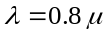m 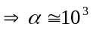cm
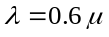m 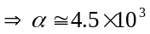cm
Let 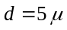m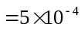cm
- For m,
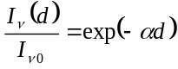
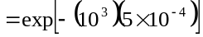
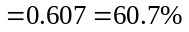
- For m,
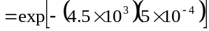
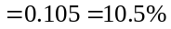
_______________________________________

Ex 14.2
For 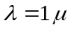m in silicon, 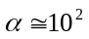cm
Now
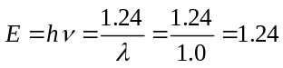eV
- 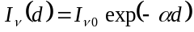
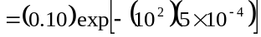
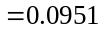W/cm
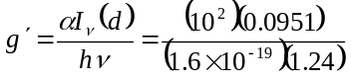
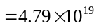cms
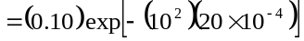
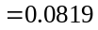W/cm
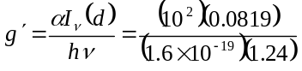
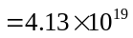cms
_______________________________________

Ex 14.3
(a) We find
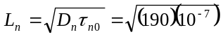
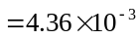cm
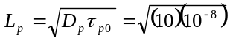
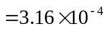cm
Now
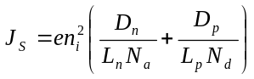
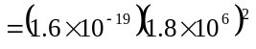
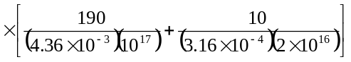
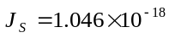A/cm
We find
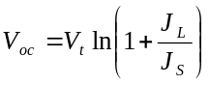
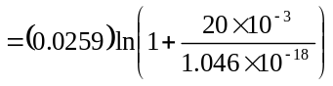
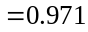V
(b)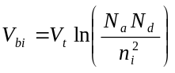
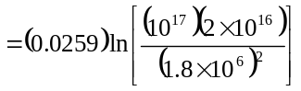
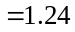V
So
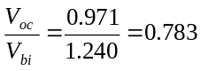
_______________________________________

Ex 14.4
The photocurrent is given by
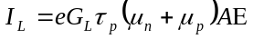
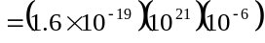
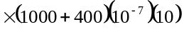
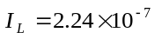A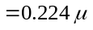A
_______________________________________

Ex 14.5
We find
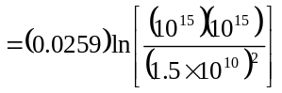
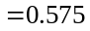V
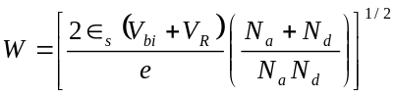
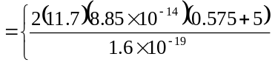
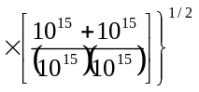
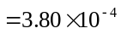cm
Then
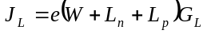
From Example 14.5, 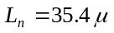m
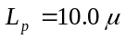m
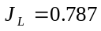A/cm
Now
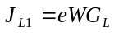
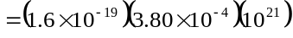
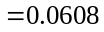A/cm
Then
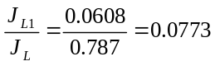
_______________________________________

Ex 14.6
- For 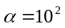cm
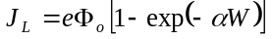
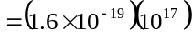
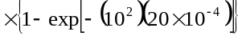
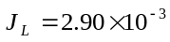A/cm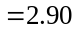mA/cm
- For 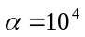cm
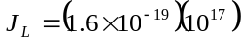
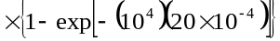
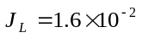A/cm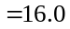mA/cm
_______________________________________

Ex 14.7
- For 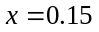, 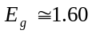eV
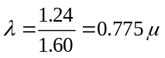m
- For 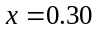, 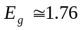eV
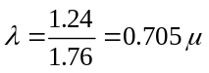m
_______________________________________

Ex 14.8
For GaAs, 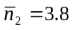
For GaP, 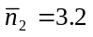
Then for GaAs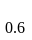P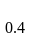,
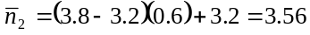
Then
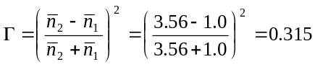
_______________________________________

Ex 14.9
For GaAsP, 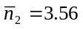 (See Exercise
Ex 14.8)
Then
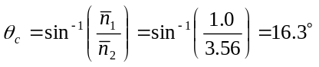
_______________________________________

Test Your Understanding Solutions

TYU 14.1
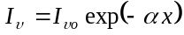
- For m, cm
(i)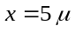m
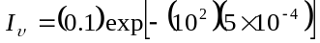
W/cm
(ii)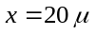m
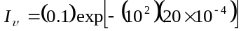
W/cm
- For m, 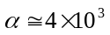cm
(i)m
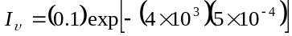
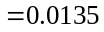W/cm

(ii) m
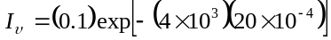
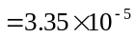W/cm
_______________________________________

TYU 14.2
From Example 14.3, 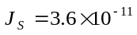A/cm
Now
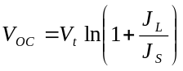
We have
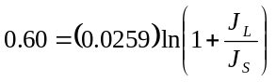
which yields
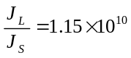
or
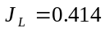A/cm
_______________________________________

TYU 14.3
From Example 14.3, A/cm
We have 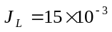A/cm
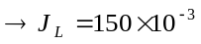A/cm
Now
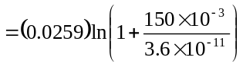
or 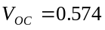V
_______________________________________

TYU 14.4
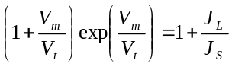
So
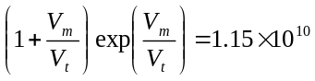
By trial and error,
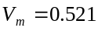V
We have 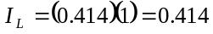A
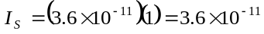A

Then
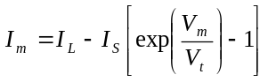
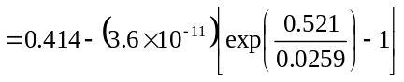
or 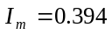A
So
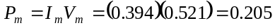W
_______________________________________

TYU 14.5
Use results from Example 14.5;
We have 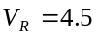V
Then
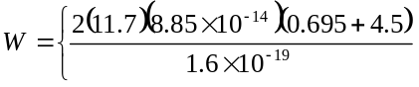
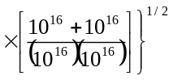
or 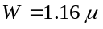m
Now
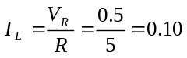mA
Then
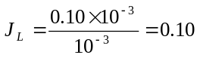A/cm
We have
and
which yields
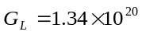cms
For m, cm
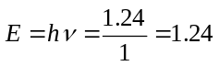eV
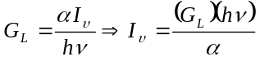
or
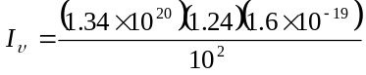
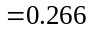W/cm
_______________________________________

